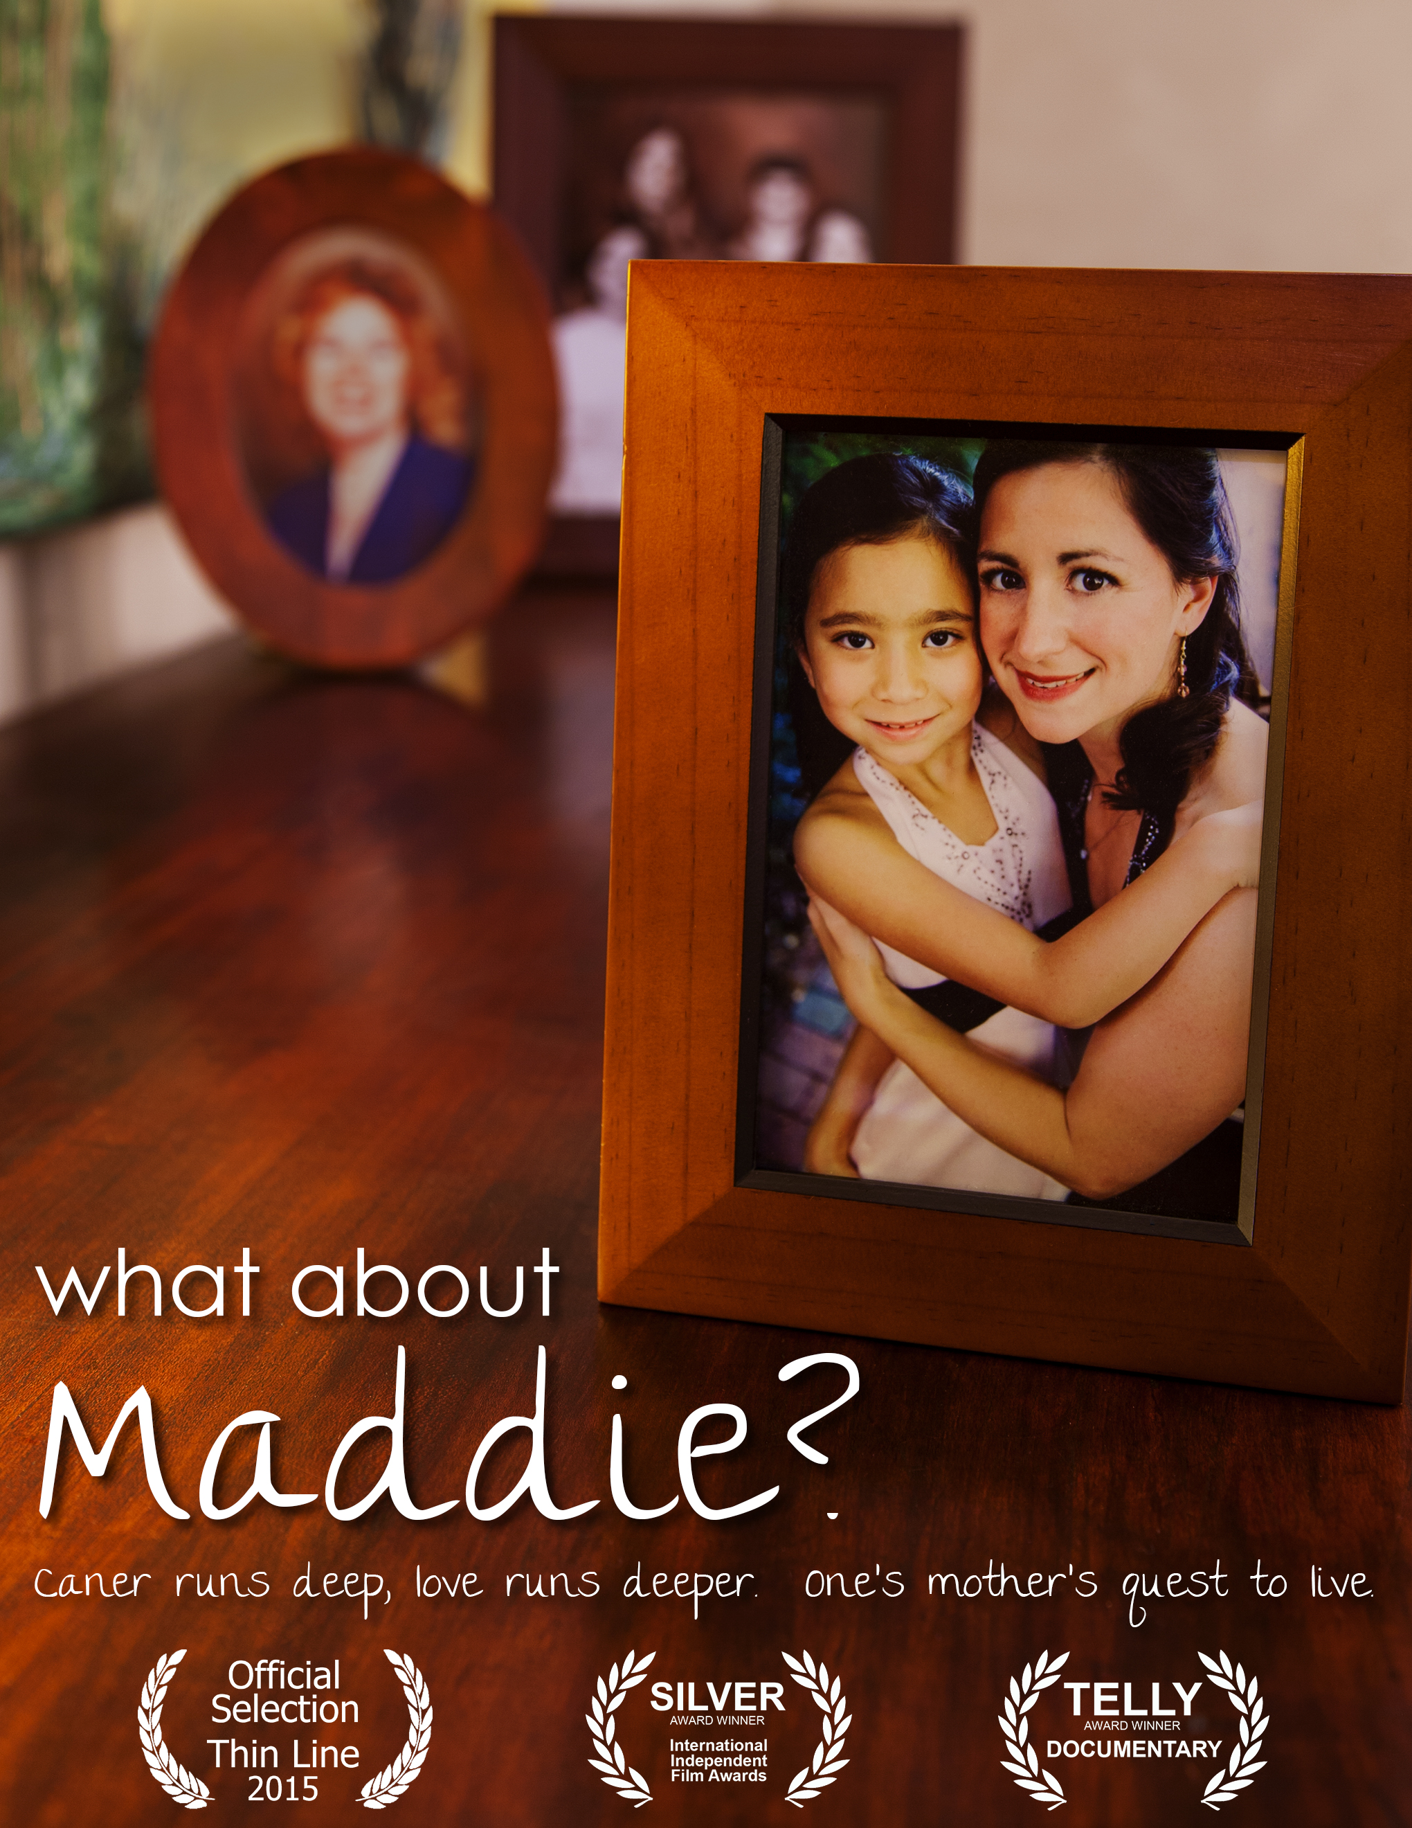
A Documentary Short by Footpath Pictures, Inc.

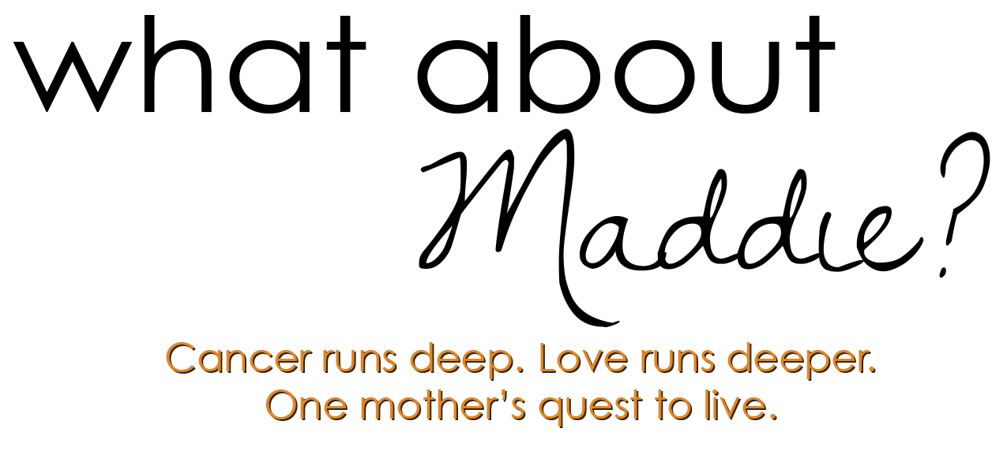

Press Kit

Contacts:
Footpath Pictures Ray Ellis, Director Susan Ellis, Producer
610-103 Hillsborough St. (919) 219-0672 (919) 600-2434
Raleigh, NC 27603 ray@footpathpictures.com susan@footpathpictures.com
(919) 833-1455
www.footpathpictures.com

Film Festivals and Awards:
- World Premiere at the Thin Line Festival in Denton, Texas – February 21st, 2015
- Silver Award Winner, International Independent Film Awards, Los Angeles, November 12th, 2014
- Telly Award Winner, Documentary Category, 2014

Logline and Synopsis
“What about Maddie?” is a documentary short that traces the journey of a young woman trying to escape the hereditary breast cancer that killed her mother. Facing a double mastectomy and the fear of passing the disease to her own daughter, questions arise as she discovers an astonishing truth.

Angie is a young mom to eight-year-old Maddie. After losing both her mother and aunt to breast cancer and testing positive for BRCA-1, Angie realizes she must remove both of her breasts if she wants to be there to care for Maddie as she grows up. Angie documents her journey through a radical double mastectomy surgery that she hopes will change her fate. The process brings back the grief of losing her own mother at such a young age. The eternal bond between mother and daughter across three generations of women comes to light in this emotional story of life, death and the boundless tenacity of love.

Exhibition and Credits
Exhibition Format: HDCam, TRT 18:30
Sound Format: Stereo

A Production of…………………………………Footpath Pictures
A Film by………………….…….…..................Susan Ellis, Ray Ellis
Produced by…………………………...............Angie Ma, Susan Ellis, Ray Ellis
Edited by…...……………….………................Ray Ellis
Videography...…………………….……………Ray Ellis, Angie Ma
Original Music by…...………………...............Rod Abernethy
Directed by……………………………………..Ray Ellis
Sound Design…………………………………..Eric Johnson, Willie Elias
Color Correction………………………………..Ron Anderson
Website………………………………………….http://www.whataboutmaddie.com
Twitter…………………………………………..@whataboutmaddie
Facebook……………………………………….facebook/whataboutmaddie

Featuring:
Angie and Maddie Ma. Introduction by actress, Samantha Harris

Contacts:
Footpath Pictures Ray Ellis, Director Susan Ellis, Producer
610-103 Hillsborough St. (919) 219-0672 (919) 600-2434
Raleigh, NC 27603 ray@footpathpictures.com susan@footpathpictures.com
(919) 833-1455
www.footpathpictures.com

Film Summary
Thirty-year-old Angie is a young mom trying to escape the hereditary breast cancer that killed her mother Lisa in 2001. After testing positive for the BRCA-1 breast cancer gene, she documents on film her journey through the radical double mastectomy she hopes can alter her fate. Compounding the impact of surgery is Angie’s haunting grief for Lisa, the threat of passing breast cancer to her beloved eight-year-old daughter, Maddie, and the fear of dying before Maddie ever grows up.
In this 19-minute documentary (much of it self-filmed), warm family scenes are interwoven with unflinching candor. At bedtime, Angie and Maddie talk about the cancer that took Grandma Lisa’s life, and the raw facts of the surgery that could change their own. Later, alone at the mirror, Angie sees her mother’s body reflected there. “Her breasts are what killed her, and mine are going to try to kill me some day.” She finds it ironic that some people think she’s brave to get her breasts removed, insisting, “Brave has nothing to do with it. I’m terrified of cancer.”
The terror is well founded. Three days after surgery, Angie hears the truth. Her pathologist has discovered both intraductal and invasive cancers in the excised breast tissue. Previous mammograms and MRI’s had completely missed them.
Angie’s life has been saved by the preventative surgery. She knows now that she can live to be there for her daughter, and is deeply grateful that she won’t have to undergo the horrors of breast cancer treatment that her mother suffered through.
But a sobering issue remains: Angie’s fear of passing the cancer gene on to Maddie is one step closer to reality. Since Lisa’s cancer was found in her mid-forties and Angie’s was already beginning at thirty, Maddie could be more at risk and will need testing before she’s twenty.

In addition, Angie must have her ovaries removed, and is then scheduled to see the same doctor who attended to her mother – exactly nine years to the day of her mother’s death. Sitting red-eyed and vulnerable on her bed, Angie talks to her camera. It becomes clear that the reality of more surgery is not what upsets her. She confesses, simply, that returning to the same waiting room where she’d sat with her mother, hearing her news, nine years later, was like torture.
The mystery of love between mother and child comes to light as Angie speaks. She can’t imagine anything worse than not seeing one’s own child grow up, hopes that her mother can somehow see her and know how much she’s missed. “And if she had some hand in this amazing fate, that I would be able to be here for my daughter, well that would be just like her.”
Angie recalls the doctor telling her mom that she had about a year to live. A montage of old home videos show how quickly that life fell apart in just a few months: Lisa smiling as she pulls a knit cap over her bald head, then voicing love for her daughter, then being wheeled out, puffy and exhausted to Angie’s graduation just weeks before dying. But the sorrow and fright in Lisa’s eyes - even as she smiled for her daughter’s camera - is undeniable.
Angie knows her mother’s sacrifice for her daughter was profound. “Until you’re a mother yourself, you can’t imagine how much you can love another person.” In the closing scene Angie and her husband visit the memorial where she leaves a letter for Lisa, thanking her for her energy, for helping to make sure that Maddie will have a mom. She says, “The gift that I have now is that I get to watch Maddie grow old.”
Cancer may remain a spectre in their world, but Angie is now focused on hope, and on seeing Maddie through whatever lies ahead. Filming her journey with a balance between pragmatism and heartbreak, the eternal bond between mother and daughter across three generations comes to light in this emotional story of life, death and the boundless tenacity of love.

Director’s Statement by Ray Ellis
When Angie approached me about the possibility of producing a breast cancer documentary, my answer was a heartfelt yes. At the age of seven I lost my mother to breast cancer when she was only forty-six. Two of my four sisters are breast cancer survivors who were diagnosed at age thirty-nine and forty-one. My other two sisters elected to have double mastectomies and reconstruction surgeries because as one put it, “It was like having two loaded guns pointed at my chest.” This was in the mid 1990’s before the BRCA-1 breast cancer gene had been identified, so their decision was considered unconventional, drastic and extreme.

Since that time and the discovery of the gene mutations, this surgery is not nearly as rare, especially given that women who test positive for BRCA-1 or BRCA-2 have an 85% chance of developing breast cancer at some point in their lives.

Angie was only thirty years old when she tested positive for the BRCA-1 gene late in 2009. Her mother’s cousin, Alden, who was dying of breast cancer, urged her to get tested and to do whatever was necessary to be able to have the chance at life. Alden knew Angie’s chances of getting breast cancer were high given Angie had lost her mother, Lisa, to cancer nine years earlier when Angie was a senior in college. The family history was not on her side.

Angie made the tough decision to have a double mastectomy and reconstruction in 2010 instead of waiting and risking the chance at cancer. Angie had an eight-year-old daughter, Maddie, and the thought of not being there for her or to see her grow up was not an option.

The story of Angie’s loss of her mother and the decisions she faced about her own health and survival hit very close to home for me. It was a story that needed to be told

and a story I desperately wanted to tell. Our original goal was to make sure that at-risked women were made aware of their risks and searched out the information and testing they needed to make the decisions that were best for them.

“What about Maddie?” became so much more. Besides the overriding issue of cancer, what shone through was the love of mother and child across three generations. With Angie at the center, we see the overwhelming love and grief for a mother who passed and the unconditional, maternal love for a daughter. Maddie gave Angie the strength to face her fears and her past.

I hope that after watching this film, women will take a second look at their family history, but I also hope the audience is moved by the pure element of love between Angie, Lisa and Maddie. I know of no other bond stronger than parent and child.

My wife and I founded Footpath Pictures in 2002 dedicated to telling stories that reflect a social awareness on topics ranging from health and human need, peace and reconciliation, education and the environment. These types of stories easily get overlooked and can slip away before the world takes notice. We hope to be privileged to catch a few of those stories and present them in a way so the world pauses, just for a moment, and shares in what we’ve learned.

Production Notes
During early discussions with Angie about filming the entire process of the double mastectomy and reconstruction, I felt like Angie needed to have a small HD camera available at any time. The process was going to take twelve months and the camera would allow her to record herself at any time or moment when she felt moved by emotions or the need to speak what was on her mind. This would also allow her to speak honestly and openly without the possible filter she might add if someone else was in the room filming her. What Angie captured of her alone and with Maddie gives this film its heart.

“What about Maddie?” was shot in 2010 and 2011. Post-production completed in January 2014. Actress, Samantha Harris’s introduction was shot in October of 2014. It was filmed in High Definition 1080/30p on the Sony PDW-F350 XDCam HD camera, a Sony HDV camcorder and edited on Final Cut Pro 7. The exhibition format is HDCam with a total runtime of 18 minutes 30 seconds. Additional footage was assembled from the families’ home movies and pictures.

Funding for the film provided by Footpath Pictures, Inc.

Actress Samantha Harris films introduction to the Footpath Pictures’ Documentary Short, “What about Maddie?”

Raleigh, DATE 11/14/14 - Actress Samantha Harris has filmed an introduction to the Footpath Pictures’ documentary short, WHAT ABOUT MADDIE? it was announced today. Harris is the former host of “Dancing with the Stars” and frequent correspondent with E! Entertainment Television.

WHAT ABOUT MADDIE? traces the journey of a young woman trying to escape the hereditary breast cancer that killed her mother. Facing a double mastectomy and the fear of passing the disease to her own daughter, questions arise as she discovers an astonishing truth.

This past winter, Harris was diagnosed with cancer after finding a lump in her right breast. After considering all the options, she chose to have a double mastectomy in May followed by reconstruction. She announced last month that she is officially cancer free.

Filmed in Los Angeles in early October, Harris’ two-minute introduction shares her personal story and urges all women with a family history of breast cancer to consider getting tested for the BRCA-1 and BRCA-2 gene mutations.

“We are extremely grateful to Samantha for wanting to be part of WHAT ABOUT MADDIE?, said director, Ray Ellis. “Her participation in the film will help us reach many more at-risk women and bring attention to hereditary breast cancer and the options available.”

The film is currently being submitted to U.S. film festivals.

WHAT ABOUT MADDIE? is directed by Ray Ellis; produced by Susan Ellis and Angie Ma; Music by Rod Abernethy; Edited by Ray Ellis. www.whataboutmaddie.com

About the Filmmakers
Ray Ellis is co-founder of Footpath Pictures, a documentary production company dedicated to inspiring social change through film. A director, cinematographer and editor, Ellis has worked with commercial, non-profit and broadcast clients producing projects that enlighten, engage and inspire. Ellis' most recent feature film documentary, "Certain Proof" is airing on the cable premium channel, Starz Entertainment and available for download from iTunes. Since 2003, Footpath has produced dozens of documentaries for clients including CARE (Peru), The Nature Conservancy (Guatemala, Namibia) and Cross Cultural Solutions (Costa Rica). Previously, he was Manager of Producers at Alternate Route Studios and Manager of External Product Development at SouthPeak Interactive.

Susan Ellis started her career in 1988 working as an Associate Producer and later Producer in corporate and commercial video and film productions. In 1996, she became the Creative Director for SouthPeak Interactive where she oversaw the creation of all film, video and graphical game assets. Following the events of 9/11, Susan, along with her husband Ray, decided to leave commercial production to pursue a more meaningful career. Ultimately, she discovered the power of documentaries and now uses her producing and writing skills to help non-profit organizations share their stories with the world.
Angie Ma is a Lead Teacher and Toddler Curriculum Coordinator for Montessori school in North Carolina. Angie received her AMI Assistants to Infancy (birth to 3 year-old) certification from The Montessori Institute in Denver, Colorado in 2008 and completed a Masters in Montessori Education from Loyola University in 2009. As a teacher, guiding children and families at such a dynamic time is deeply rewarding, but learning from these young experts about living joyfully has been an even greater experience. Angie Co-Produced, “What about Maddie?”, filming many of the scenes herself giving the audience unique insights filled with honesty, emotion and sincerity.

Footpath Pictures is a documentary production company dedicated to inspiring social change through film. Their subject matter includes public education, the environment, health and human needs, and peace and reconciliation. Whether capturing sacred places in Guatemala, the endangered Black Rhino in Namibia or the wisdom of a child fighting cancer, Footpath finds stories that have the potential to truly engage audiences and offer hope and vision for a better tomorrow. In addition to raising public awareness, their films have played an integral role in raising millions of dollars for non-profit organizations here and abroad.

Production Stills
To download Hi-Res images, go to: http://whataboutmaddie.com/press-2/

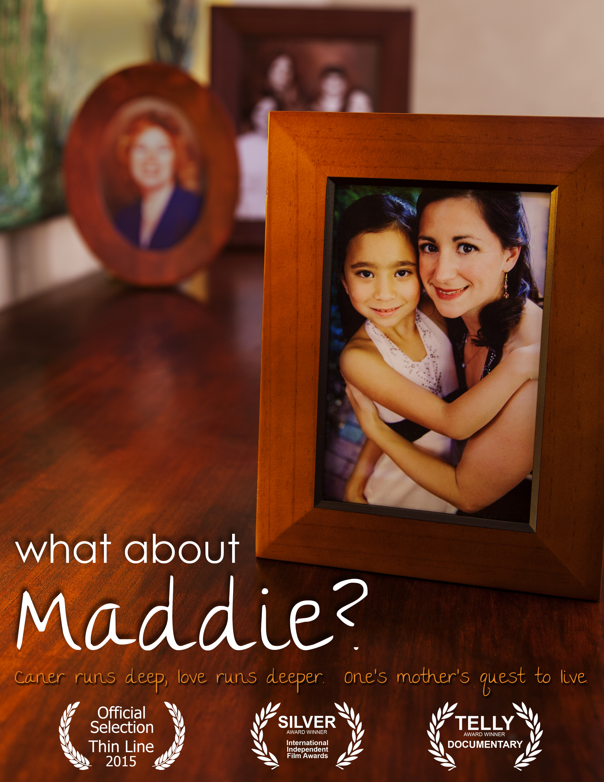
“What about Maddie?” Poster

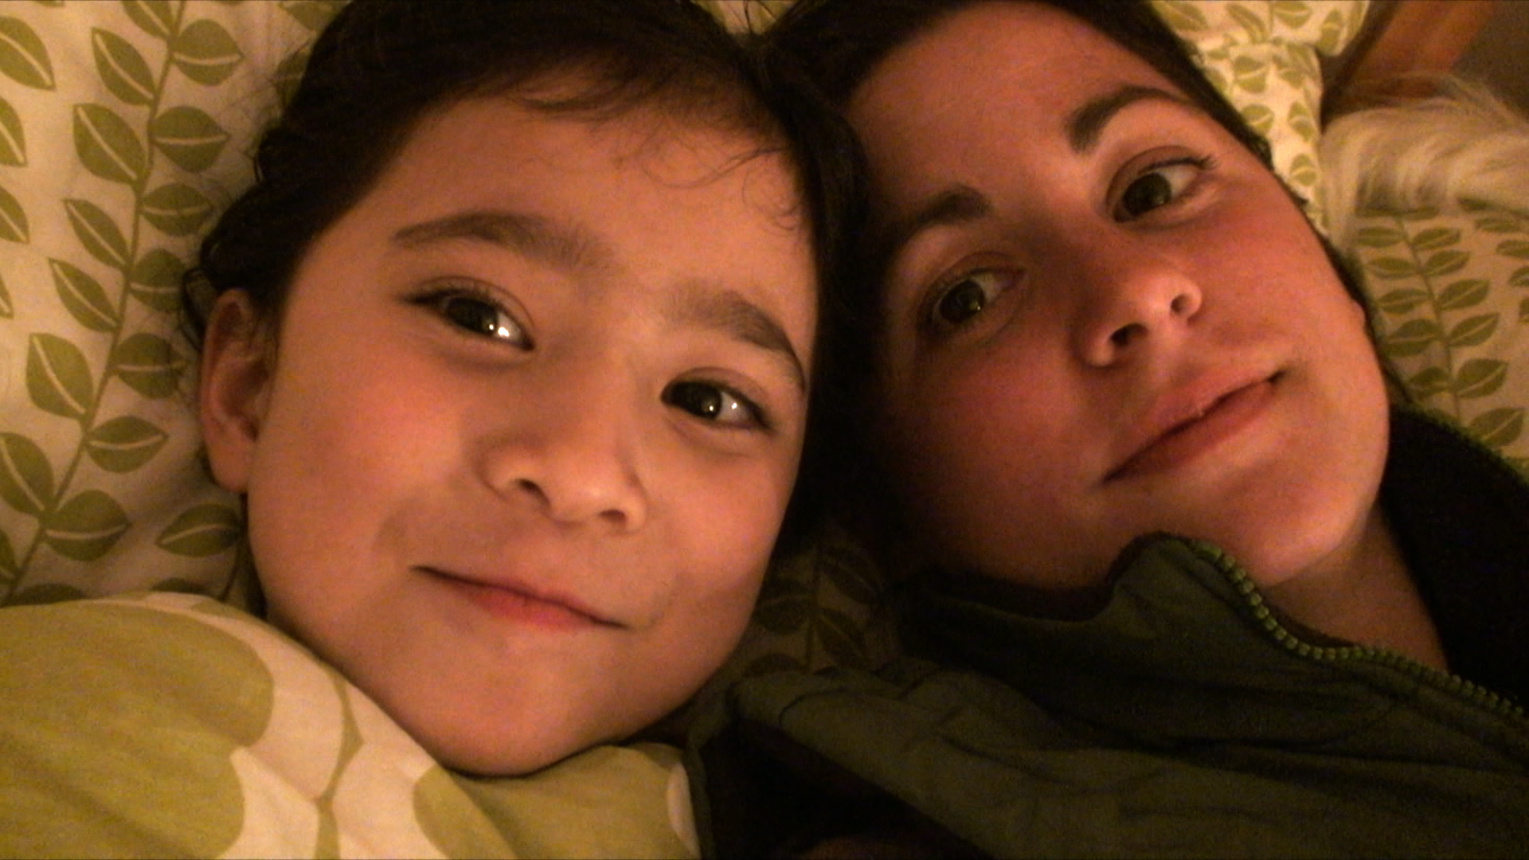
Maddie and Angie

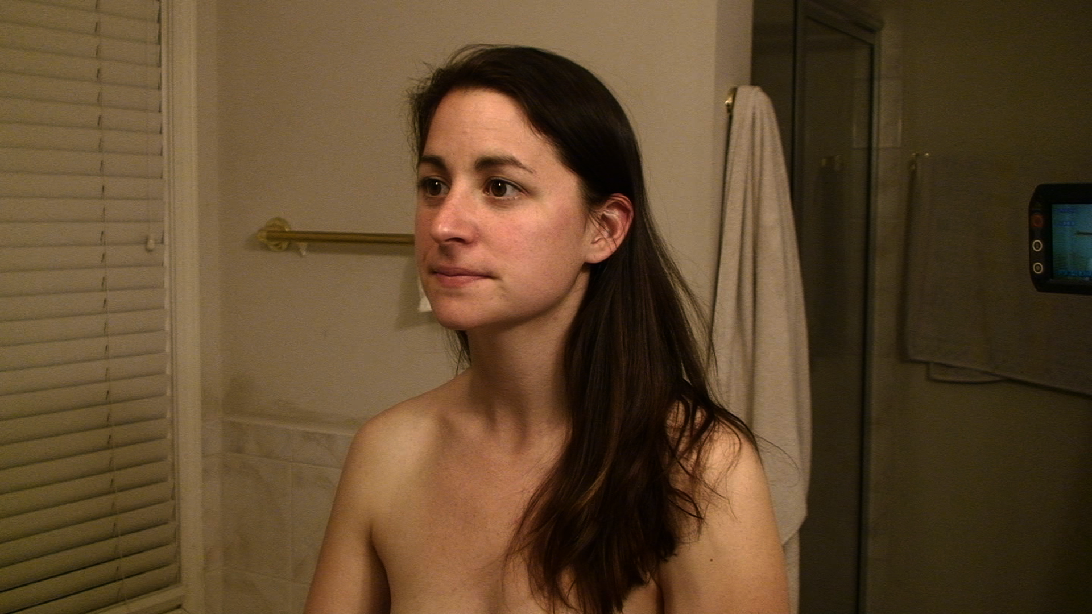
Angie at the bathroom mirror

Actress, Samantha Harris films introduction

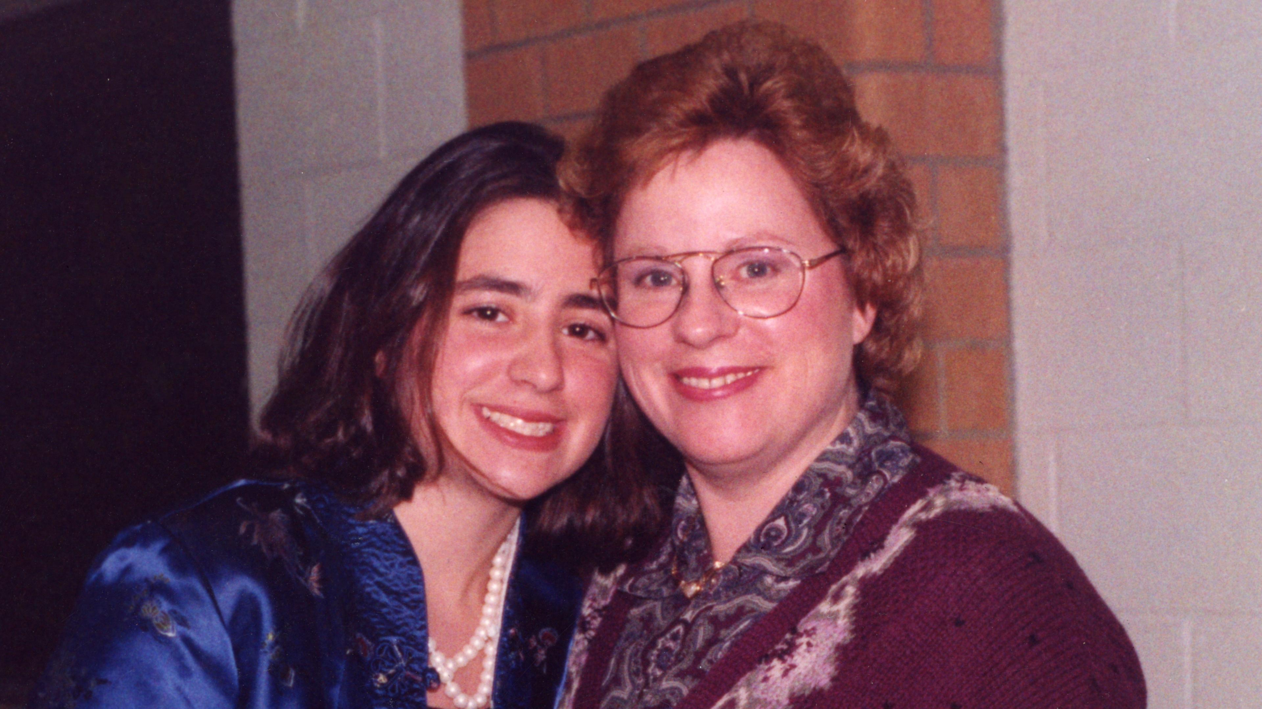
Angie with her mother, Lisa

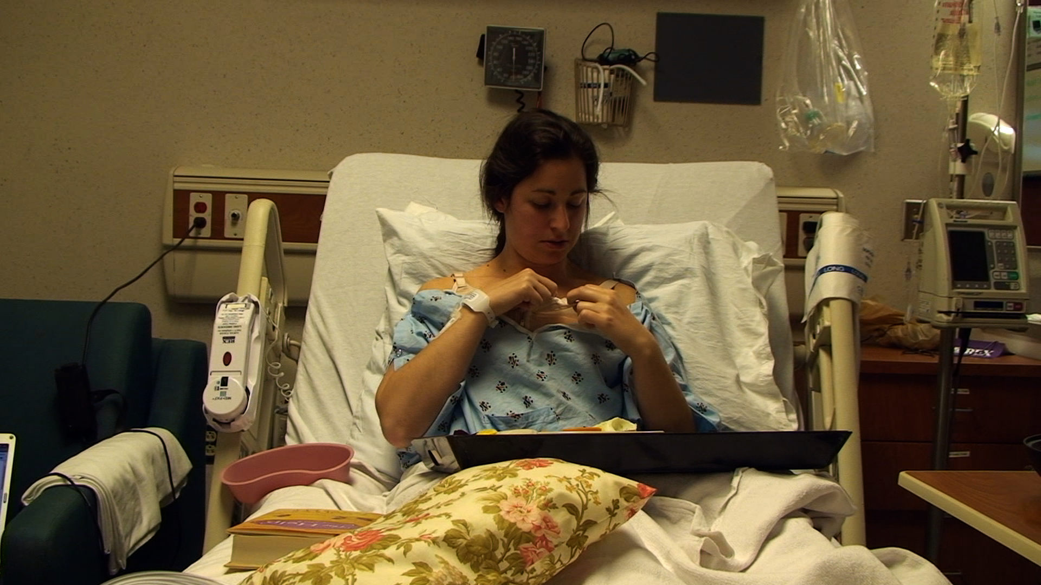
Angie following surgery

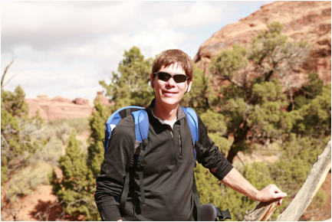
Ray Ellis, Director, “What about Maddie?”

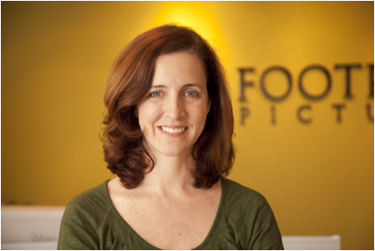
Susan Ellis, Producer, “What about Maddie?”

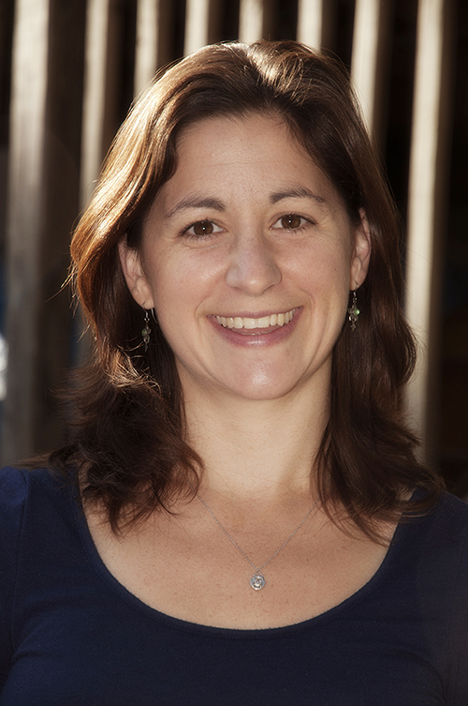
Angie Ma, Producer, “What about Maddie?”

